Description

|  |  |  |  |
| --- | --- | --- | --- |
| **Carboxylic Acid Derivatives** | **Formed from -COOH by...** | **Suffix** | **Cyclic Naming** |
| **Amide** | Ammonia or an amine | -amide | Lactam |
| **Ester** | An alcohol | -oate | Lactone |
| **Anhydride** | Another COOH | anhydride | Anhydride |

Steric Effects

* Steric hindrance can be used to control where a reaction occurs in a molecule
  + SN2 reaction will not happen at tertiary carbons
    - Force SN1 reaction instead
  + Use protecting groups by first reacting the aldehyde or ketone with two equivalents of alcohol to produce a nonreactive acetal or ketal
    - Prevent aldehydes and ketones from readily reacting with strong reducing agents like LiAlH4
    - Deprotection can be done to regenerate the carbonyl with aqueous acid

Electronic Effects

1. Induction: refers to the distribution of charge across σ bonds. Affected by:
   1. Electronegativity
      1. The less electronegative atom acquires a slightly positive charge while the more electronegative atom acquires a slightly negative charge
      2. Nitrogen is less electronegative than oxygen
   2. Distance
      1. Effect is weaker with increasing distance from the electronegative atom
   3. Number of electron-withdrawing groups
      1. Anhydrides have 2, which leaves a significant partial positive charge on the electrophilic carbon
2. Conjugation: refers to the presence of alternating single and multiple bonds
   1. Creates delocalized π electron clouds above and below the plane of the molecule
   2. Electrons experience **resonance** through unhybridized p-orbitals, increasing stability
   3. Conjugated carbonyl-containing compounds are more reactive because they can stabilize their transition states

Reactivity to nucleophiles

* Anhydrides >> Esters >> Amides

Anhydride Cleavage

* Cleavage reaction, which is also a nucleophilic acyl substitution reaction

1. Ammonia + Anhydride → Amide + Carboxylic Acid

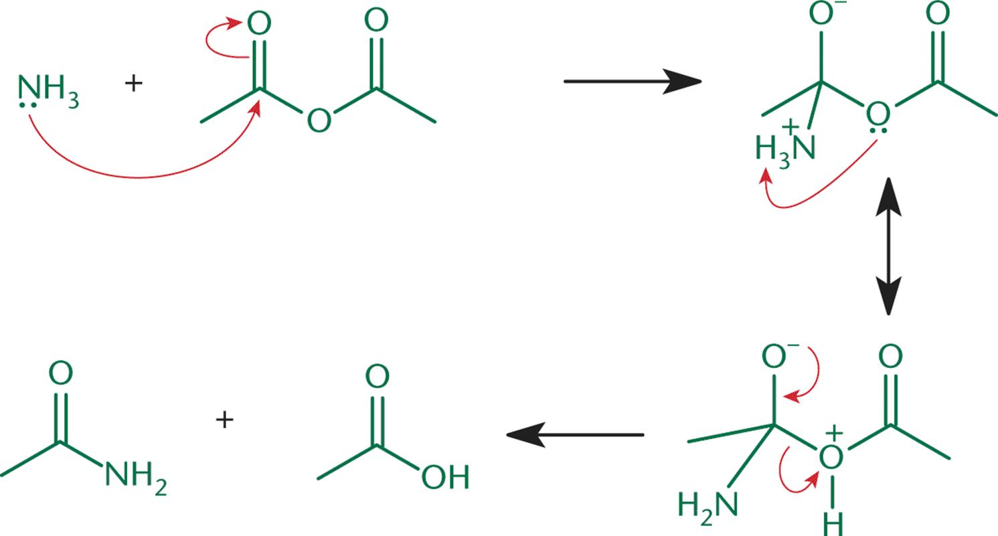

1. Alcohol + Anhydride → Ester + Carboxylic Acid

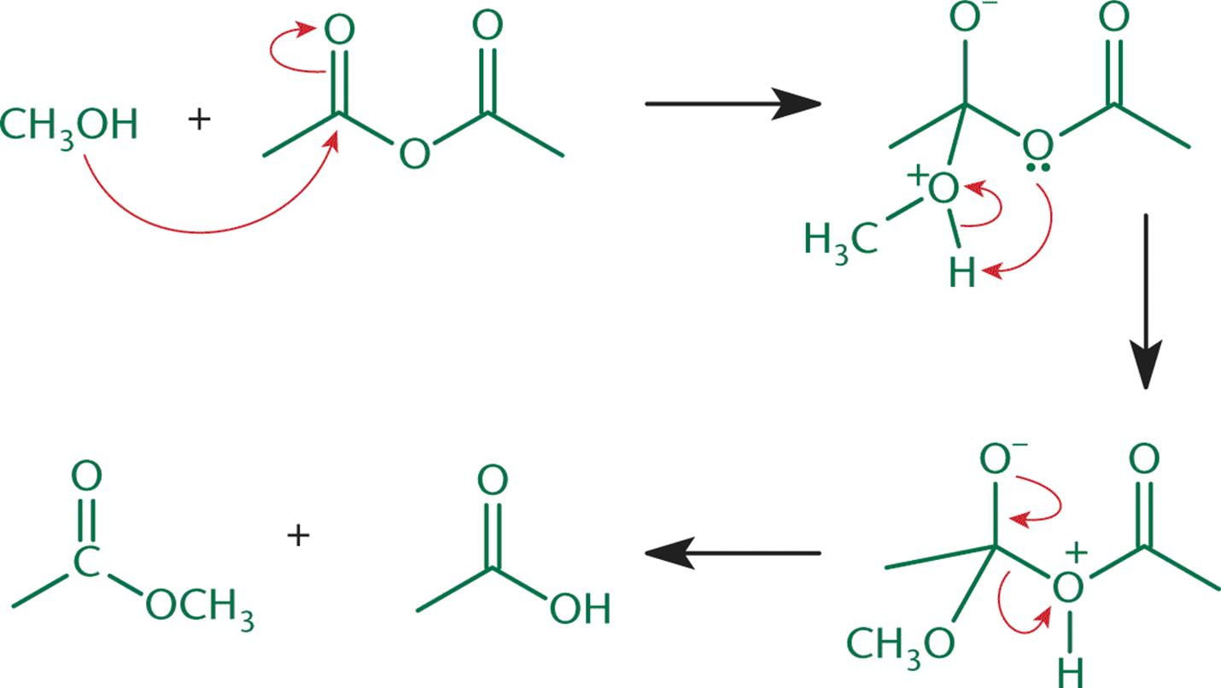

1. Water + Anhydride → 2 Carboxylic Acid

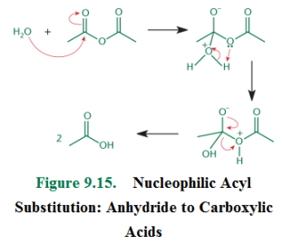

Transesterification

* Alcohols can act as nucleophiles and displace the esterifying group on an ester

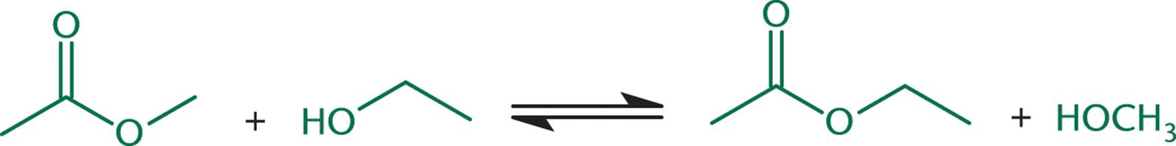

Hydrolysis of Amides

* Strong base or acid is needed to catalyze the hydrolysis of amides, which are normally quite stable
  + Strong acidic condition: H+ can protonate the carbonyl carbon, making the molecule more susceptible to nucleophilic attack by a water molecule (shown below)
  + Strong basic condition: OH- acts as the nucleophile on amide carbonyls, and eventually produces a deprotonated carboxylate anion
* This is the reverse of the condensation reaction by which amides are formed (by carboxylic acid and ammonia)

